 |  | VGHF Digital Collection Policy 2026

Style Guide
- Use [DO/DONT] or [YES/NO] for policies - It makes it clear that this document can be changed in the future with well thought reason
  - Use [YES/NO] for firmly actionable guidelines. Use [DO/DON'T] for general practices.
- Messaging with examples will be the most powerful (E.g.,)
- Policies > Strategies > Plans || Synthesize policy into strategies and then into action plans for strongest effect
- Dates/events that may need changing in future revisions of this document are bolded and bracketed. Ex: [August 2027] or [Coming Soon]
- Project Opportunities are noted in [Bold] as they also may cause changes on future review
Contact us with submission or donor request via Email, Bsky, Discord, or Patreon
Requests to donate that do not comply with our collection policy will be discarded

Collection Criteria
Inclusion
- Physical materials from the library that have been digitized and have no other additional access restrictions
- Materials that enhance the contexts of materials already in the collection, such as regional variants or different versions
  - The collection will then be updated to reflect these contexts as appropriate
- Mass print materials: Magazines, Art, or Flyers
- [YES] Development materials: Design documents, Concept Art, Memos
- [YES] Unique materials not currently represented in the collection.
  - E.g., materials that complete a set (such as a games magazine collection), relevant contextual materials for other objects in the collection.
Exclusion
- Any physical library holdings that are still pending digitization may be missing for now
- Materials with legal restrictions
- Materials with contractual restrictions
- Material that cannot be safely or adequately transferred or stored and are better left where they are
  - This will be evaluated for every acquisition for the long-term safety of the materials.
- [NO] Videogame prototypes
  - (USE: Gaming Alexandria and Hidden Palace)
- [NO] Non-development materials: Merchandise
- [NO] Game data for dumping
  - (USE: HitSave.org)
- [NO] Hardware: Controllers, Consoles
  - (USE: Strong National Museum of Play or University Michigan LibGuide)
- [NO] Retail videogames
  - (USE: Our wonderful local retro games stores)
- [NO] Access to playable videogames
  - (USE: Archive.org)
- [NO] Web materials: Websites, Game Reviews
  - (USE: Archive.org)
- [NO] Literature about games: Strategy Guides, Game Development Books, Novelizations, Theory, Non-Games Magazines with Single Games Issues [Project Opportunities!]
  - (USE: The Video Game Library)
- For Phil Review
  - Foreign language sources - open for submissions but can’t be administrated currently - RomChip for Japanese
    - Exclusion of non-english objects? Leave unaddressed for “case by case”?

Access Policy
Material Access
- Make digital resources accessible to those with disabilities by maintaining online accessibility standards.
Intellectual Property
- [DO] Build agreements with companies or major donors to maintain private archives with clear time-embargoes that can ensure their survival while respecting proprietary rights.
- [DO] Maintain donor-relations to manage PII rights found in materials.
Donor & Library Rights
- [YES] Donors can retain full rights to their donated items after sending them to us and we can return physical items to donors after being scanned and processed.
- [YES] Sensitive heirlooms will be shipped, handled, and returned with respect and care.
- [YES] Maintain rights to ownership of all materials within the digital library collection that are created through the digital preservation process.

Material Request
- [YES] Users may access materials available in digital library collections that do not have access restrictions at any time
- If the archive is having downtime please contact us!
- [NO] Collection materials are licensed under “non-linear access”, and do not have a limit on concurrent users
- [NO] Users are not allowed to check out any physical materials in-person from our location. There should be no time when material enters or leaves the library space without prior administrative permission.
- [NO] Check outs are not tracked by the library or web cookies in any way

Donor & Library Rights
- Donors can retain full rights to their donated items after sending them to us and we can return physical items to donors after being scanned and processed.
- Sensitive heirlooms will be shipped, handled, and returned with respect and care.
- The VGHF maintain rights to ownership of all materials within the digital library collection that are created through the digital preservation process.

Selection Criteria
Accept:
- Mass print materials: Magazines, Art, or Flyers
  - Development materials: Design documents, Concept Art, Memos
Reject:
  - Videogame prototypes
  - (USE: Gaming Alexandria and Hidden Palace)
  - Non-development materials: Merchandise
  - Game data for dumping
  - (USE: HitSave.org)
  - Hardware: Controllers, Consoles
  - (USE: Strong National Museum of Play or University Michigan LibGuide)
  - Retail videogames
  - (USE: Our wonderful local retro games stores)
  - Access to playable videogames
  - (USE: Archive.org)
  - Web materials: Websites, Game Reviews
  - (USE: Archive.org)
  - Literature about games: Strategy Guides, Game Development Books, Novelizations, Theory, Non-Games Magazines with Single Games Issues [Project Opportunities!]
  - (USE: The Video Game Library)

Donated Material Handling
Duplicate Material:
  - If VGHF library staff determine that an acquired object is in better condition than the library's existing copy, replace the object with the received item.
  - If the duplicate is in serviceable condition, add it to the items used as donation rewards. (E.g., Vintage Video Game Monthly Magazine Subscription)
  - Debound materials are an exception and will be handled at the VGHF librarian’s discretion
  - If there is something about the material that transforms the material’s context or scope (e.g., signed, or notarized), VGHF library staff may choose to treat the duplicate material as a distinct object in the collection.
  - Prioritize processing of any materials considered ‘At Risk’
  - E.g., 1-of-1s, fragile materials, or location-unstable materials
Out of Scope Materials:
  - If donated materials meet any of the exclusion criteria, but are identified as having value or are ‘At Risk’ by VGHF library staff, attempts will be made to redirect the object to an appropriate organization.
Storage strategies
  - Store materials based on accession when deemed appropriate to mitigate disruption of physical materials
Digital Library access limitations
  - Donors with outstanding rights to materials can designate limitations on materials as deemed appropriate by the VGHF and the donating party.

Digital Library Cataloging (Preservica Admin)
Arrangement
- [TOP LEVEL]: Game Materials, Development and Production Materials, Event Guides and Ephemera, Gaming Cultural Ephemera, Magazine Library, Press Materials, Promotional Materials, Research and Reports
  - Materials are separated by method of production to better identify the differences between material developed by press, industry stakeholders, and game companies themselves
- [DO] Feature collections based on newest major additions to the digital archive
- [DO] Strategically demote the portions of disproportionately bulky materials that actively get in the way of productive search results
  - The metadata of materials like this may be augmented to avoid impacting search
What is identified and prioritized within an object and its metadata?
- [DO] Prioritize organizational names, dates, and subject matters
- [DO] Develop strategies for richer metadata capture for stronger associations - [Project Opportunities!]
Condition and Valuation
- [DO] Prioritize quality over speed: At Risk media is formatted via active open-source software so that it is of the highest quality
  - We will work with other organizations or trusted parties to achieve a more appropriate level of storage, scan, or emulation of an artifact/document when applicable
- [DO] Accept donations from those who may have a better-quality document than what our archive displays
Digital documentation strategy
- [DO] Use explanatory scope notes to establish context on groups of materials
  - Especially when metadata is unusual such as for short magazine runs.
- [DO] Provide custodial histories to help provide context for how a better version of material could replace what is currently accessible in the digital archive
Cataloging rights
- [NO] Access to cataloging backend
  - This is held by the VGHF Director, the VGHF Head Librarian, and Preservica Administration.
  - The VGHF Director can provide access to relevant VGHF staff and contractors as necessary
Processing
- [DO] Retain original files of scans and their modulations
  - TIFF and Machine-readable Version as TIFF may be used for more accurate OCR translations in the future
  - A larger preservation version, a faster user-friendly access version, and a thumbnail version to identify materials

Preservation
Current Collection Storage Methods
- [YES] Physical Collection stored in house, with the following protections whenever possible:
  - Temperature controlled building
  - Shelving drilled into ground
  - UV-proofed and covered windows
  - Acid-free folders and backing boards
  - Mylar sleeves
- [NO] Shrinkwrap. Never shrinkwrap.
- [YES] Digital Collection stored on offsite server(s)
  - -FOR PHIL- Server protection?
- [DO] Checksum verification for software materials being stored
Tech Maintenance Strategies
- [DO] Prioritize price for hardware repair as some hardware is currently more expensive and risky to repair than to simply purchase again.
  - Hardware e.g., Scanners, Testing equipment, CD rippers
- [DO] Keep backup equipment on site for devices that cannot be easily replaced (high-end disk drives)
Org Preservation
- [YES] Maintain the current [5-year] resourced status
- [YES] Board of directors are responsible for rehousing materials if the primary organization becomes inoperative
Material Transfer and Re-housing
- [DO] Use verified copies in place of original materials when showcasing to not affect the rarest parts of the collection and lessen re-housing

Generative AI Usage Policy
- [NO]

Collection Scope
- Timely Strategy: The digital library collection’s collection strategies aim for projects that have rich connections to history, which means our projects are biased towards developing older artifacts from the [early 1970s] that may be on the verge of being lost or may have limited professional connections to help maintain them.
- Locality Strategy: Our collection currently reflects the organization’s American location and there is a wider games history to be found in other parts of the world, so our strategy is to assist projects that inspire and advocate for the creation of games material archives around the world as well as continuing to ally with national archival projects for mutual cultural gain.
- Subject Strategy: The history of videogames did not start with the form being called “videogames” and so there may be opportunities for the collection to go beyond games-specific magazines and into toy, tech, and media magazines that are contextually relevant to the subject. In these cases we may not provide the full run, full magazine, or even whole material. Objects of this nature are provided on a case-by-case basis.
- ‘Loss Principle’ Strategy: If there is any reason that the loss of a particular item within our means that can be in our collection would be regretted in the future, we build a case for preservation.

user warrant For Technology
The VGHF maintains this archive for many types of users in an effort to remove access barriers around videogame history. Our strategy is to continue building the collection available within the Digital Library so that our shared games history can be accessible regardless of access device, country, and language. The collection should be accessible by any user regardless of location, as long as the network resolves within the user’s country. Our collection services are designed primarily with game enthusiasts in mind as a way to learn more about the history and context related to their videogame interests. Additional consideration for videogame researchers and historians are incorporated so long as they do not impede with the enthusiast experience. Future service development may have considerations for supporting current, former, and future game developers across the game industry. To connect more users to games history, our strategy is to continue building the archive and its preservation strategies so games history can be accessible regardless of devices being used, country, and language.

This document will be revised and reauthorized by [July 2027], if today’s date is after the date printed here, please contact the owner.

[Internal Only] Full Service/Operations List
- Digital library/archive management
  - Collection processing
    - Metadata
    - Retrieval
  - Collection access
    - Access requests
    - Internal prioritization policy
    - Access portal development
- Artifact appraisal
  - Requirements
  - Procedure
  - Right of refusal guidelines
- Collection development
  - Artifact intake
    - Intake process
  - Donations
    - Donation guidelines/policy
  - Artifact deaccessioning
    - Better copy of magazine donated
- Advocacy for games and industry artifact preservation
Non-Service Operations:
- Fundraising
  - Patreon
  - Magazine subscription
  - Donation events
    - Month of giving campaign
  - Podcast
  - General fundraising operations
    - Corporate partnerships
    - Annual donors
    - Grant funding
- Public Relations
  - Patreon
  - Social media
    - Discord
    - Blusky
    - Instagram
  - Youtube
  - Events/Conventions
Opportunities for Strategic Alignments
- Research assistance and production
- Specialist collation participation
  - Fair use advocacy
- Industry contract work
  - Digital Eclipse
  - Contracted pop-up museum
- Other (Identified opportunities in alignment with mission)

Services Diagram
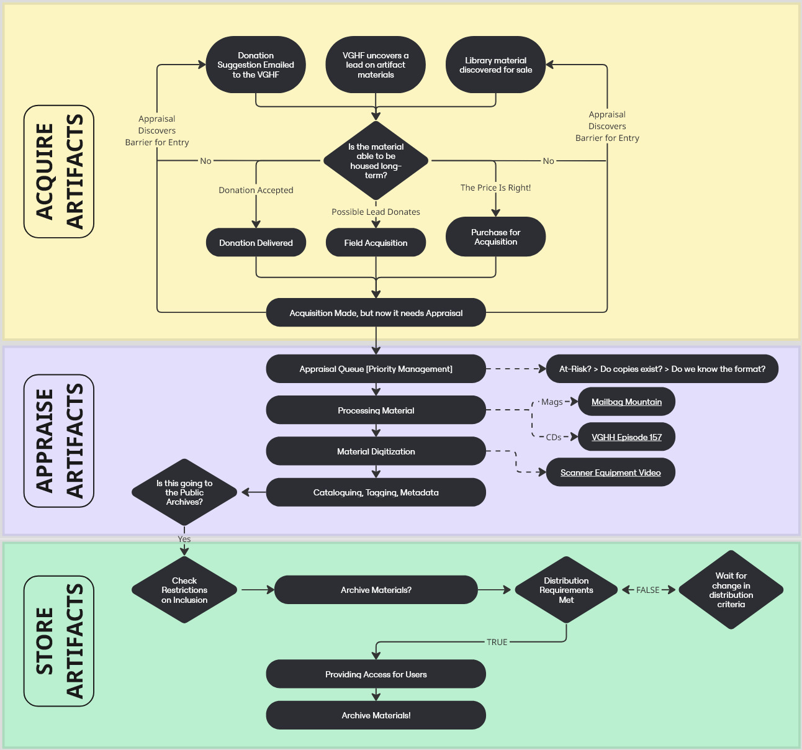
[Links in image available in larger, link robust PDF version in the Github]

‘Loss principle' concept is attributed to Ernest Lindgren, founding Curator of the National Film Archive, London - I can't find an original document for the quote, but this was noted here at Audiovisual Archiving: Philosophy and Principles, Ray Edmondson, [3rd ed.] 2016, pg. 64

